1. Screenshot of the code for the mySQL bamazon db

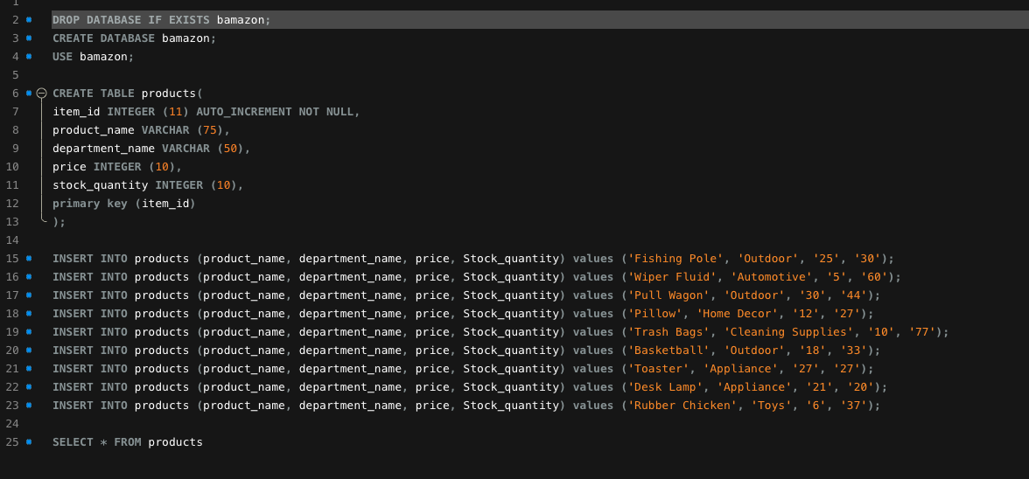

2. Screenshot of the bamazon inventory after running the **SELECT \* FROM products** command. Note that there are 44 Pull Wagons, item ID 3.

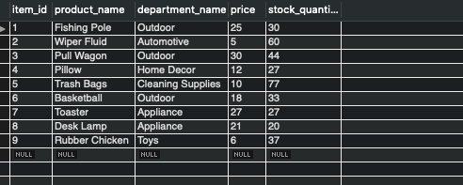

3. Results after running the node bamazonCustomer.js command:

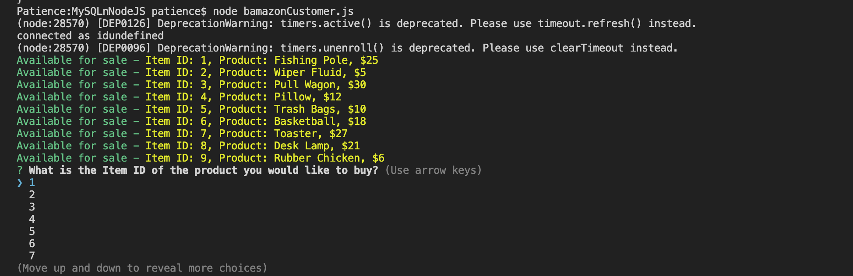

4. Selecting item #3 and a question of “how many would you like?” appears then the quantity, I entered 2:

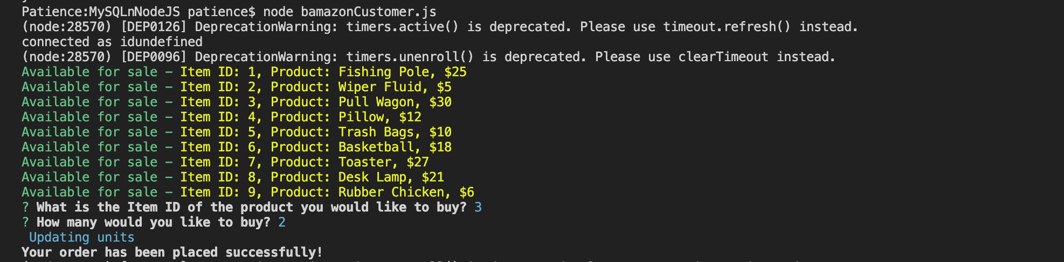

6. The number of Pull Wagons listed under “stock quantity” in the mySQL database has been reduced from 44 to 42:

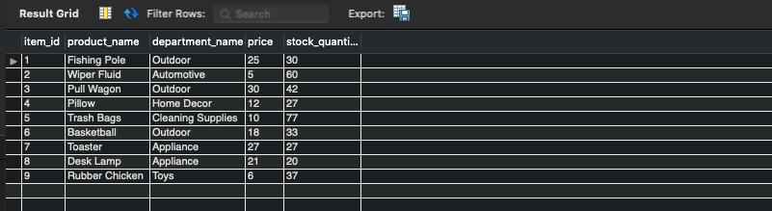

7. If steps 1 -4 are retaken and the user chooses to buy 45 Pull Wagons, or any amount greater than the stock quantity on hand, an insufficient quantity message appears:

